Create Oracle RDS instance in Amazon
Login to AWS Console and click on <RDS> under Database.
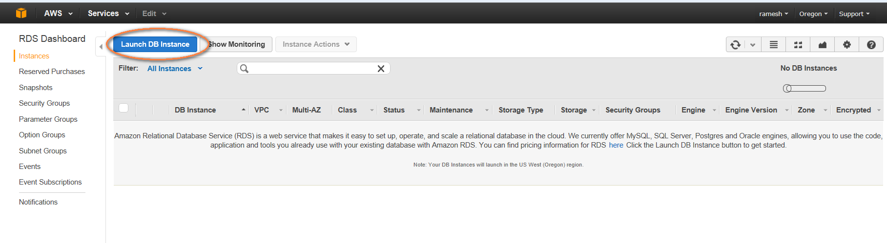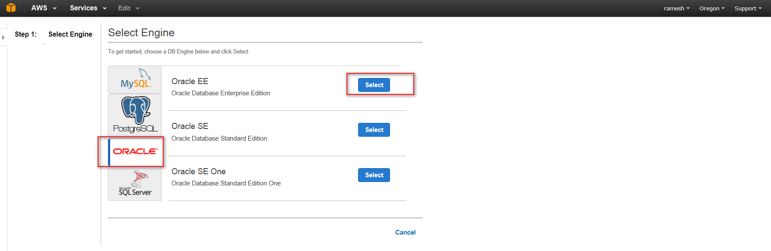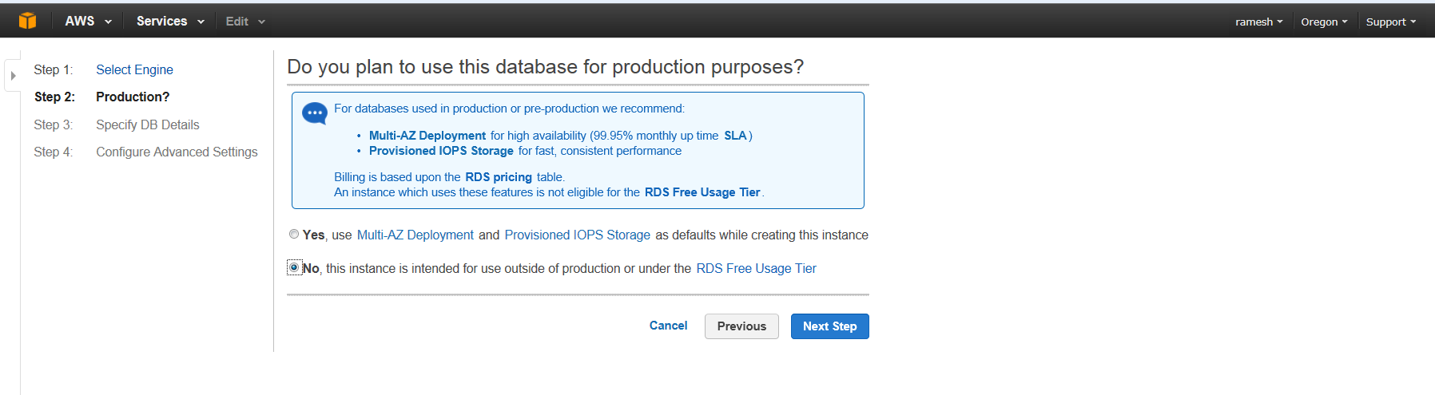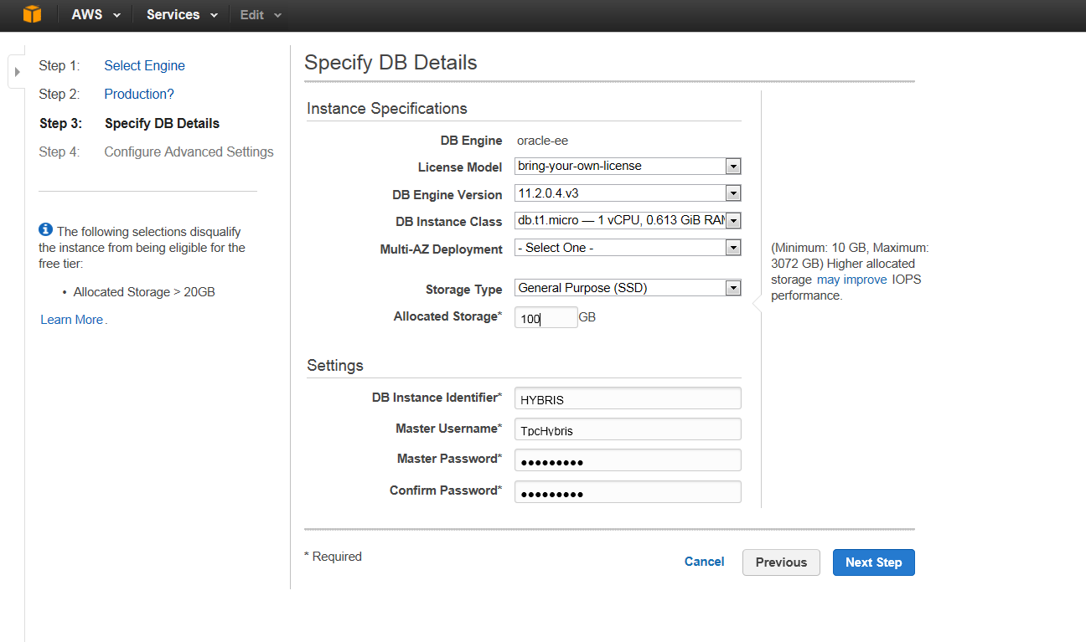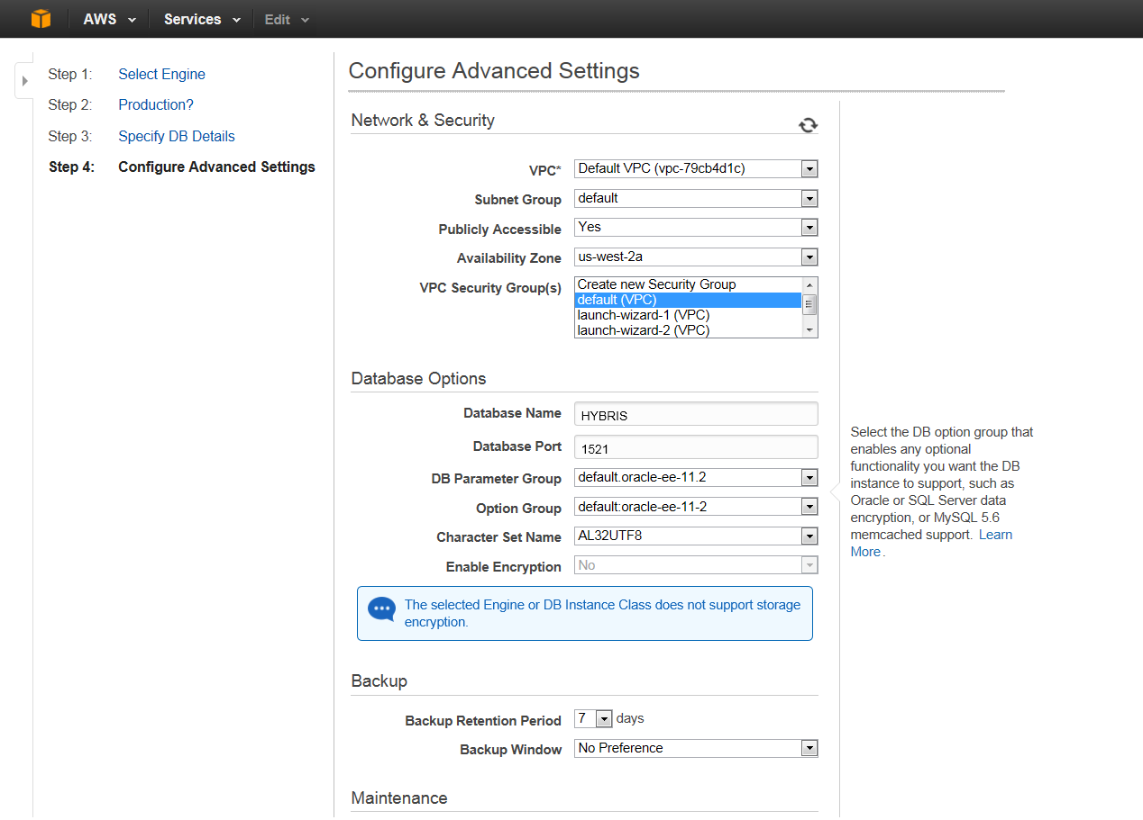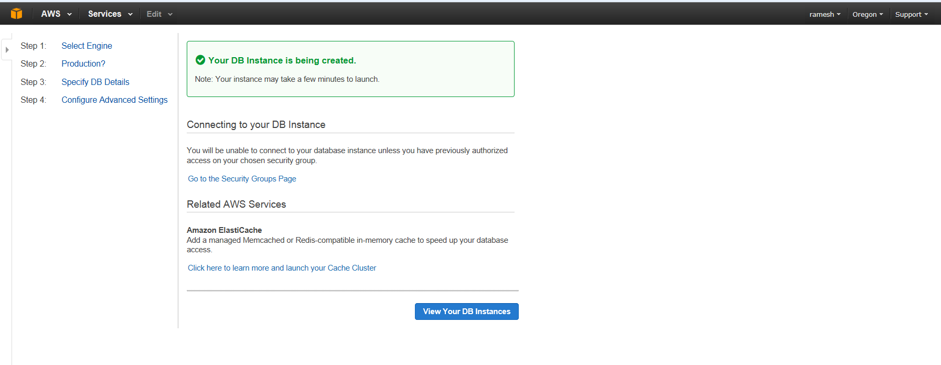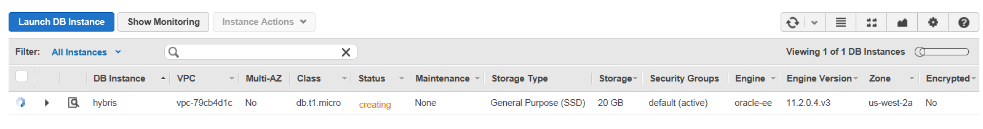
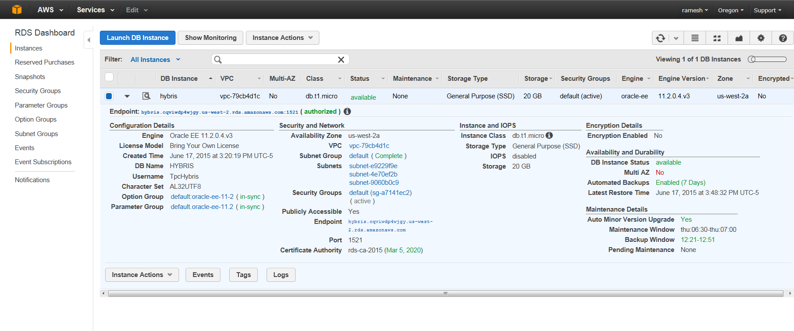

Created RDS instance as POC.
Login: https://482196046481.signin.aws.amazon.com/console
Database Name- WPRD
Master username – tpssys
Master Password - password
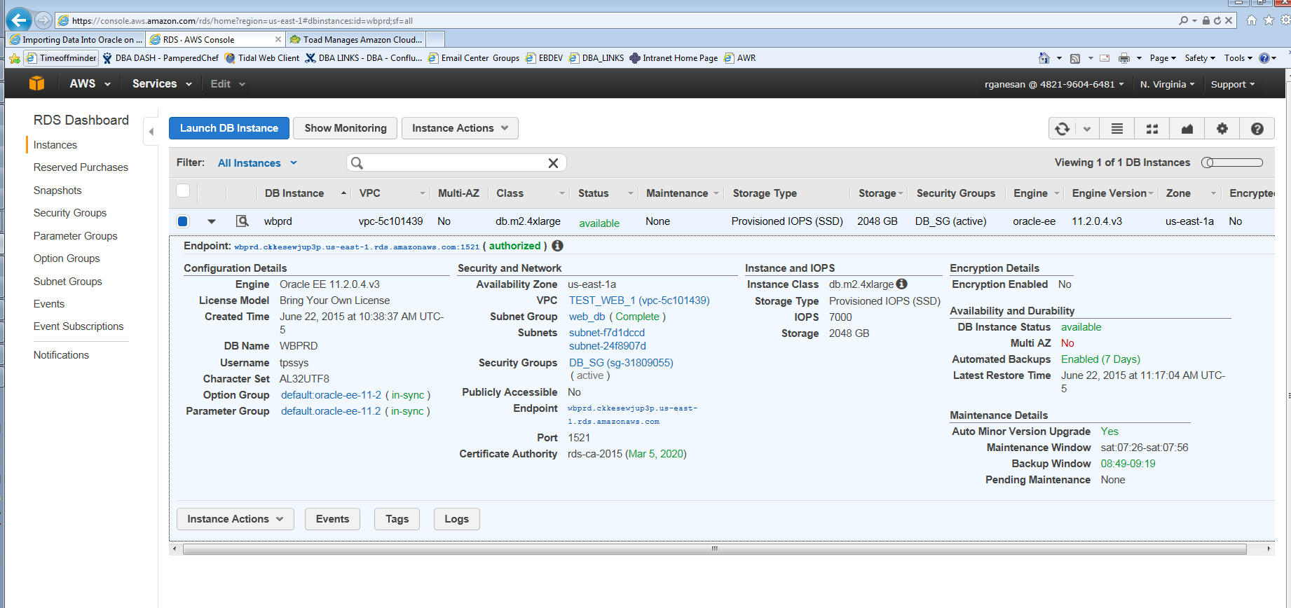
Check Connectivity from Chef Network via Telnet
- Telnet wbprd.ckkesewjup3p.us-east-1.rds.amazonaws.com 1521
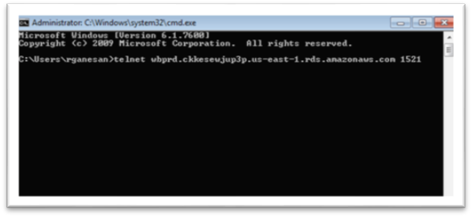
Config and Test Toad Connection
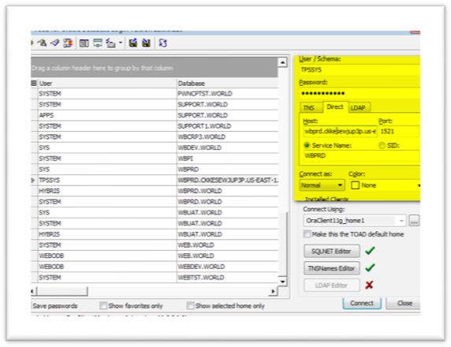
Verify Version
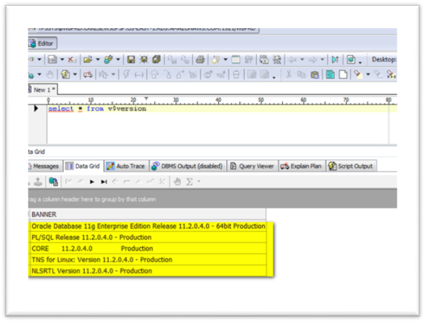
Verify Database mode
