Create instance in EC2 in AWS using AMI
URL: http://aws.amazon.com/amis/oracle/

Launch Oracle 11.2.0.1 AMI Image.
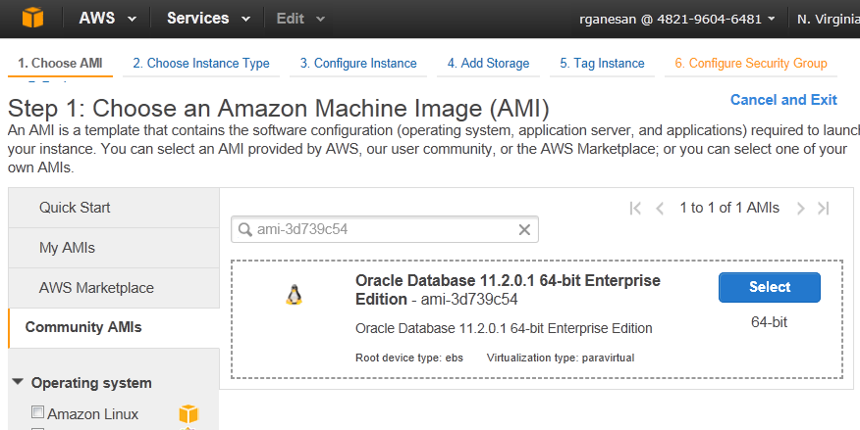
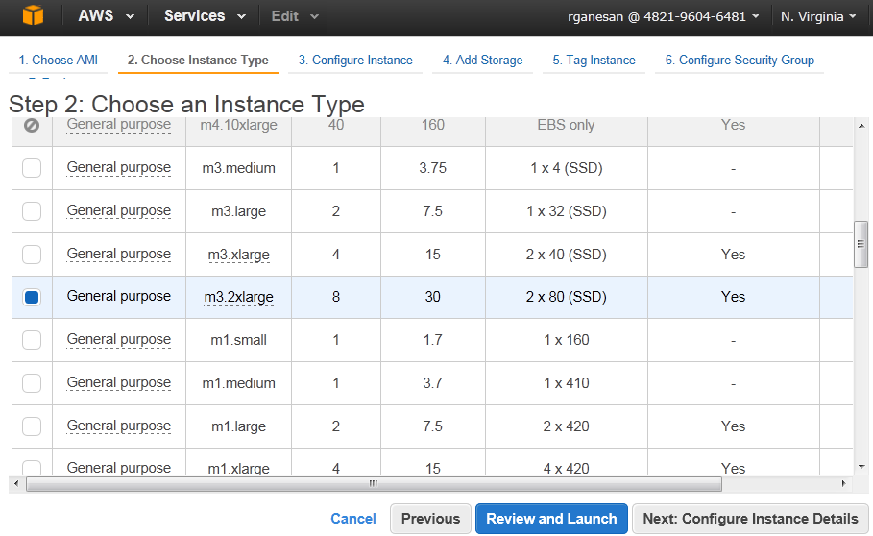
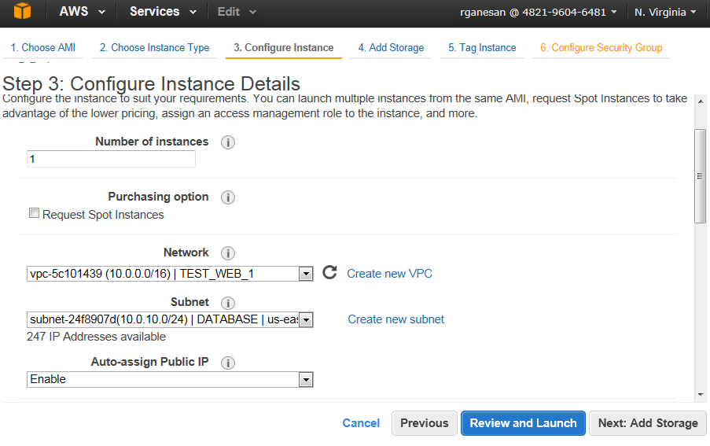
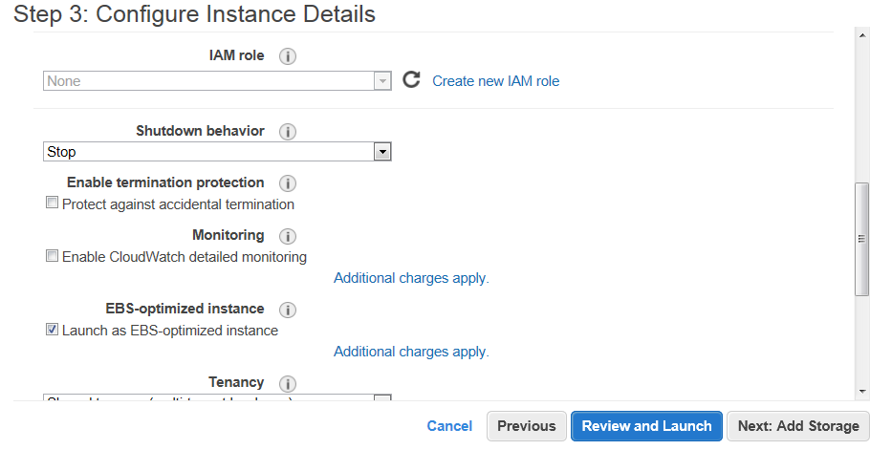
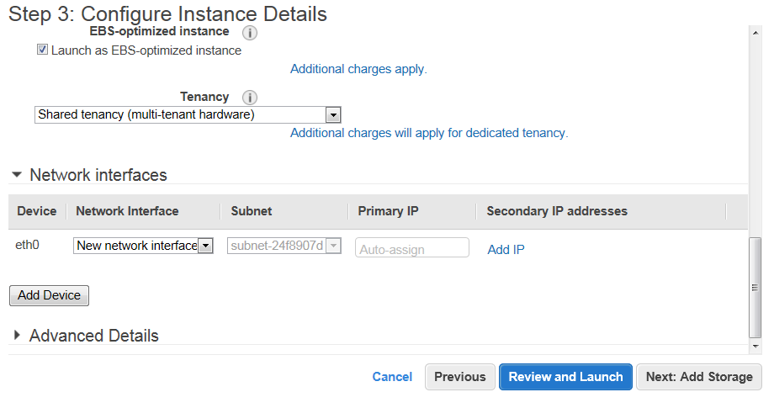
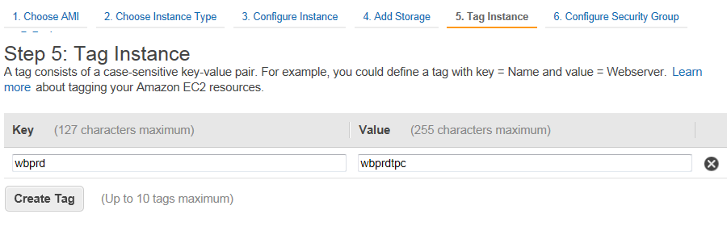
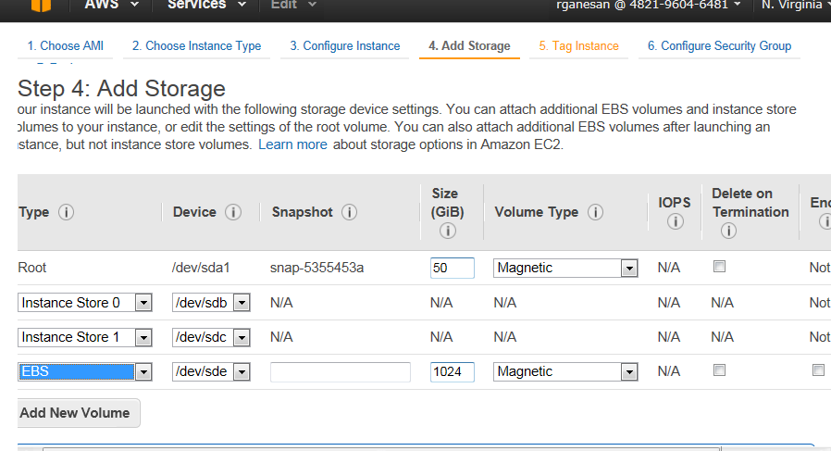
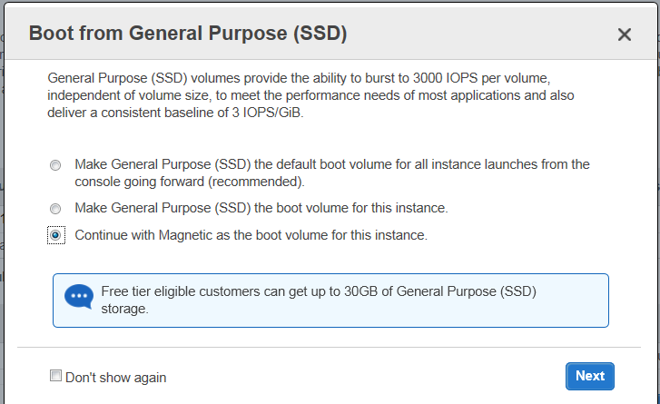
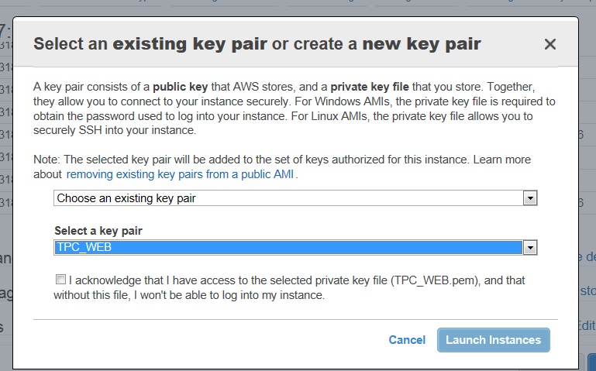

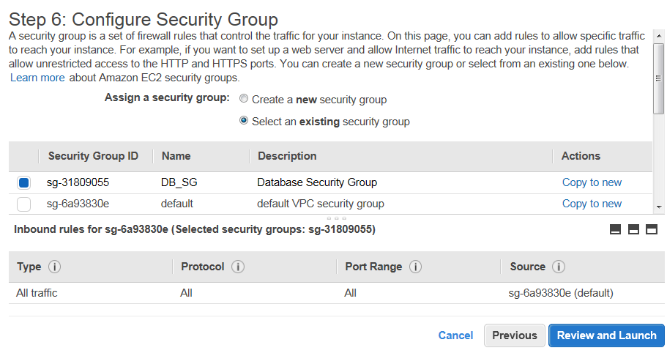

--Connect to AWS using Putty
Configure the Auth with Private key for Putty.
Get the secure pair key from Sysadmin - WEB_AWS.ppk
Host: ec2-52-4-239-87.compute-1.amazonaws.com (10.0.10.141)
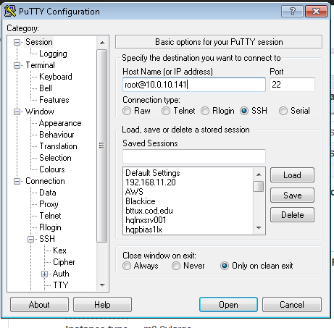

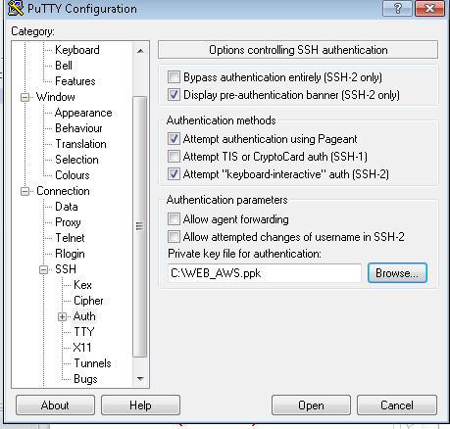
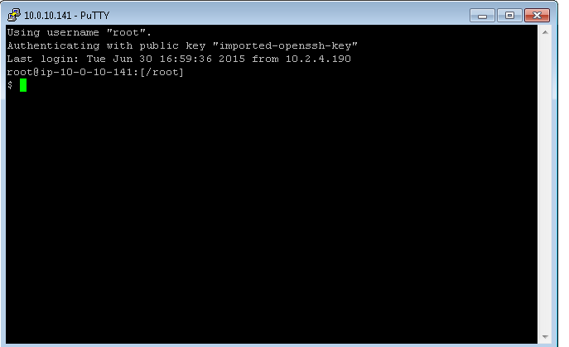

--Connect using VNC to AWS
--sysadmin to install VNC server pkg and install
--Start VNCserver
Have them open 5900, 5901 and 5902 in security group in AWS.
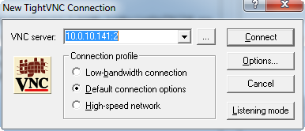
--------Sftp to AWS from local machine ------
Copy the ppk file on to your C:drive
Download psftp program on c: drive
C:\>psftp -i C:\WEB_AWS.ppk root@10.0.10.141
Using username "root"
Remote working directory is /root
psftp>
--------Sftp to AWS from rhdb04server
download the TPC_WEB.pem on /home/oracle on rhdb04
chmod 400 TPC_WEB.pem
[oracle@rhdb04 ~]$ pwd
/home/oracle
[oracle@rhdb04 ~]$ ls -ltr *.pem
-r-------- 1 oracle oinstall 1692 Jun 9 10:43 TPC_WEB.pem
[oracle@rhdb04 ~]$ sftp -oIdentityFile=TPC_WEB.pem root@10.0.10.14
[oracle@rhdb04 ~]$ sftp -oIdentityFile=TPC_WEB.pem root@52.4.239.85
--test ssh to AWS
[oracle@rhdb04 ~]$ ssh -i TPC_WEB.pem root@10.0.10.14
--test sftp to AWSoracle@rhdb04 ~]sftp -oIdentityFile=TPC_WEB.pem root@10.0.10.14

--Create Database on AWS
Login to root on AWS
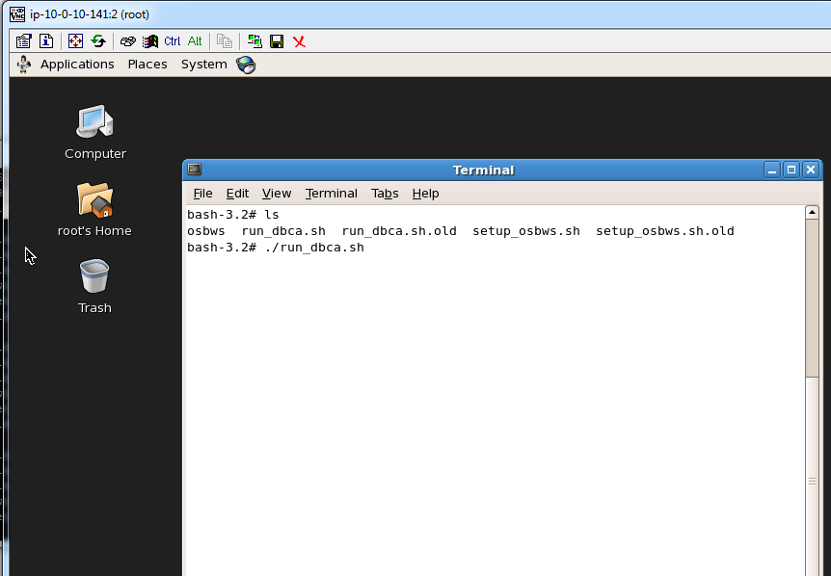
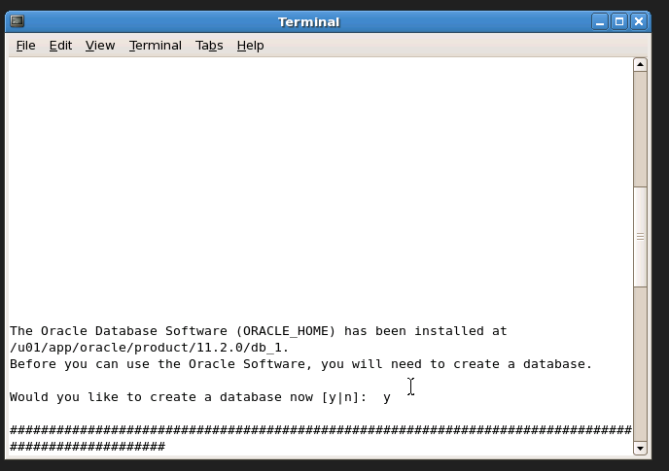
Note: we mounted /dev/sde1 is EBS storage of 1TB
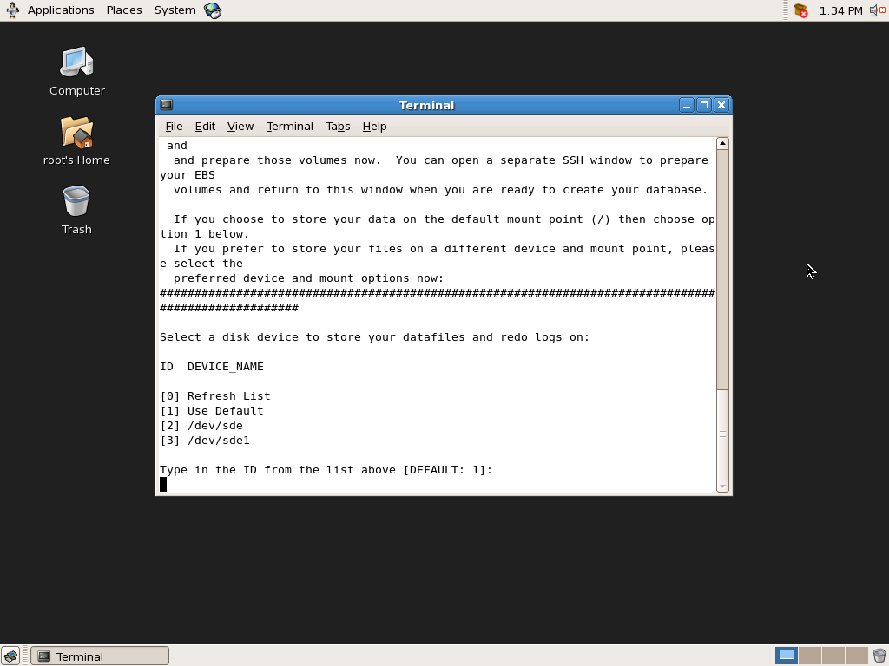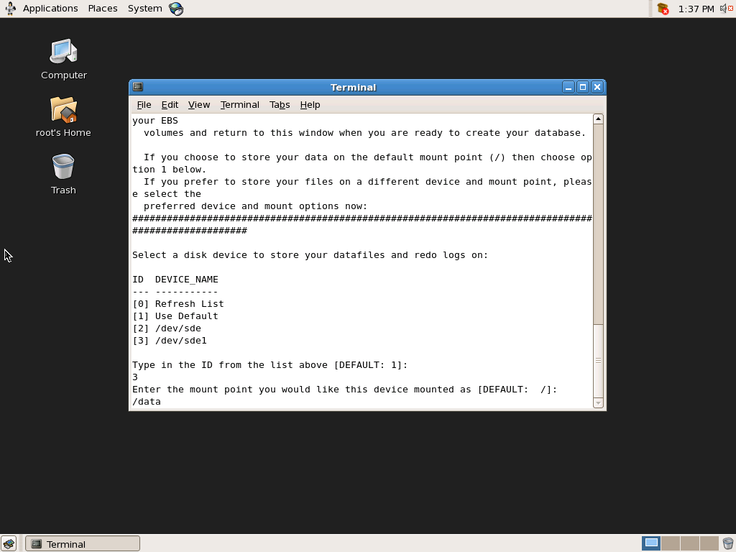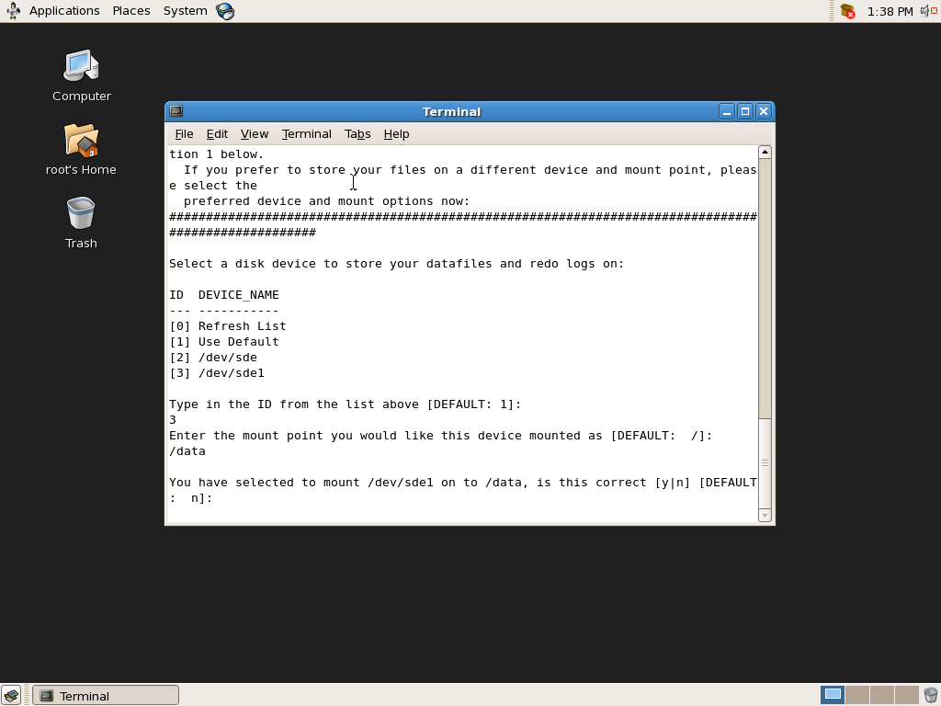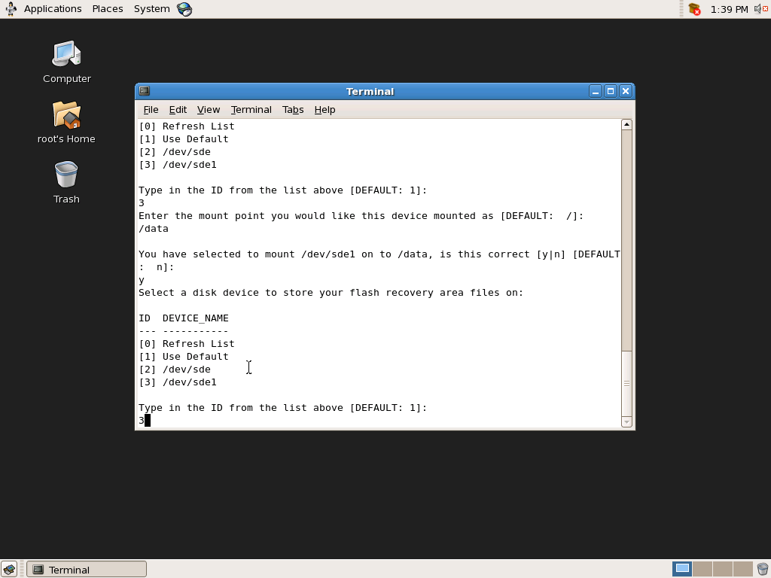
Got an error stating no disk found.
-------Invoking DBCA to create DB.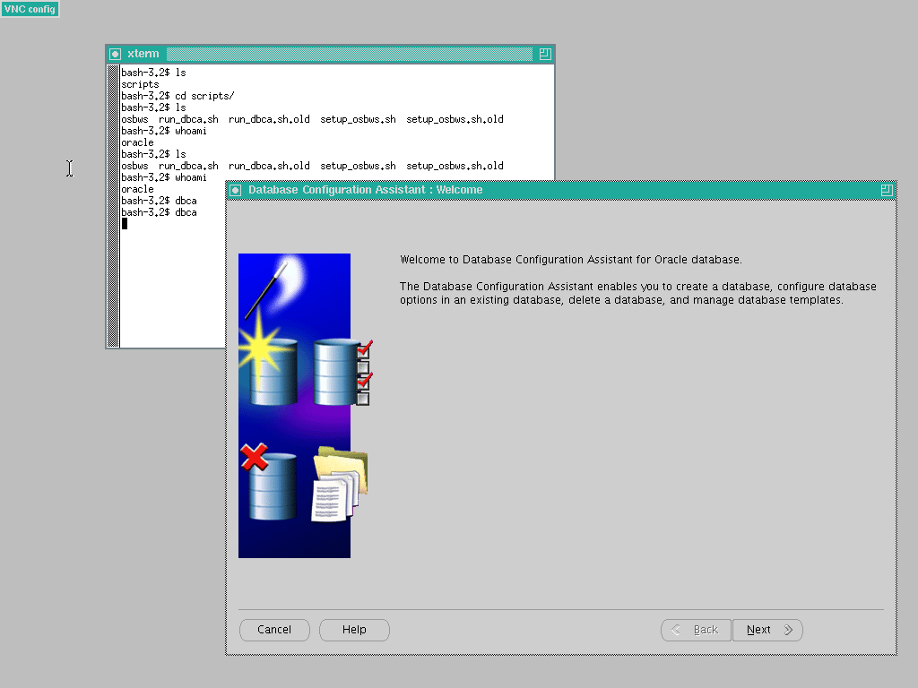 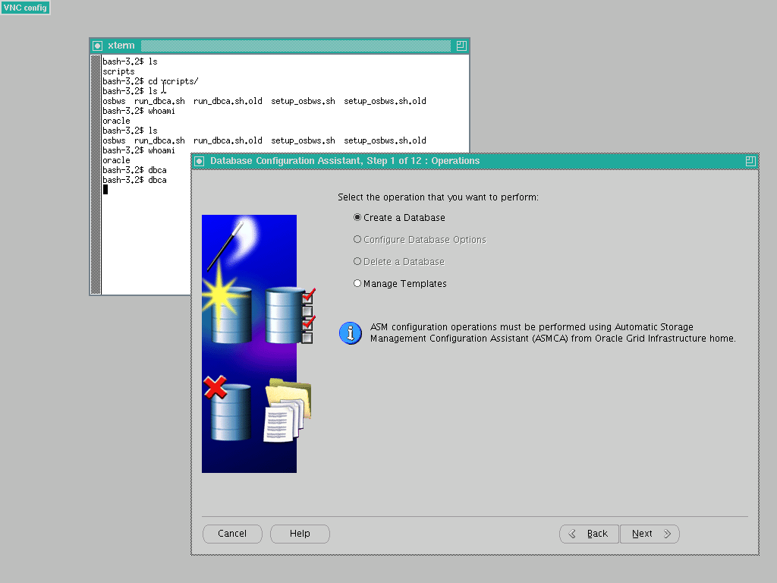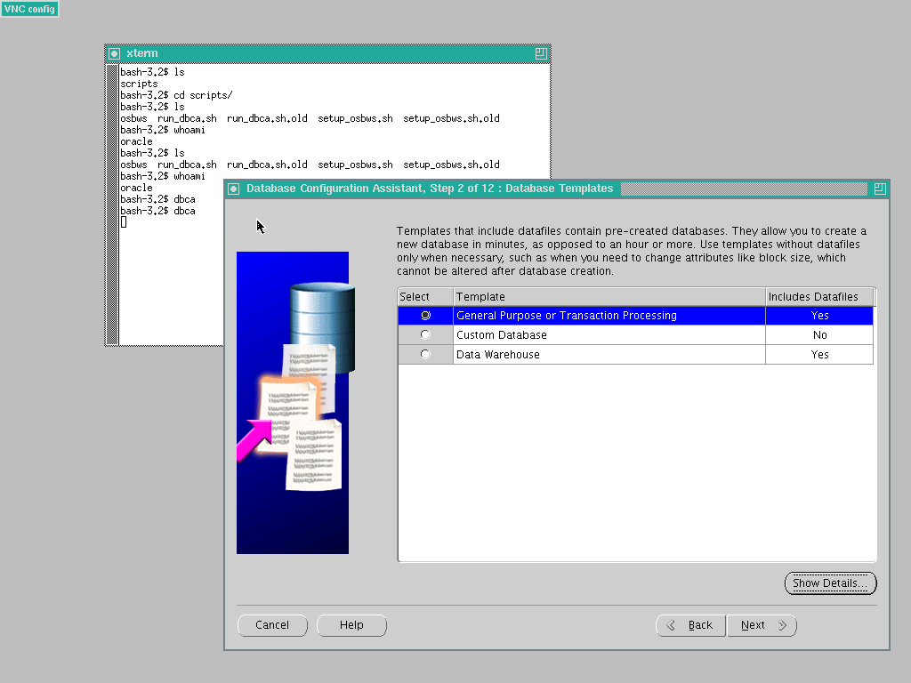 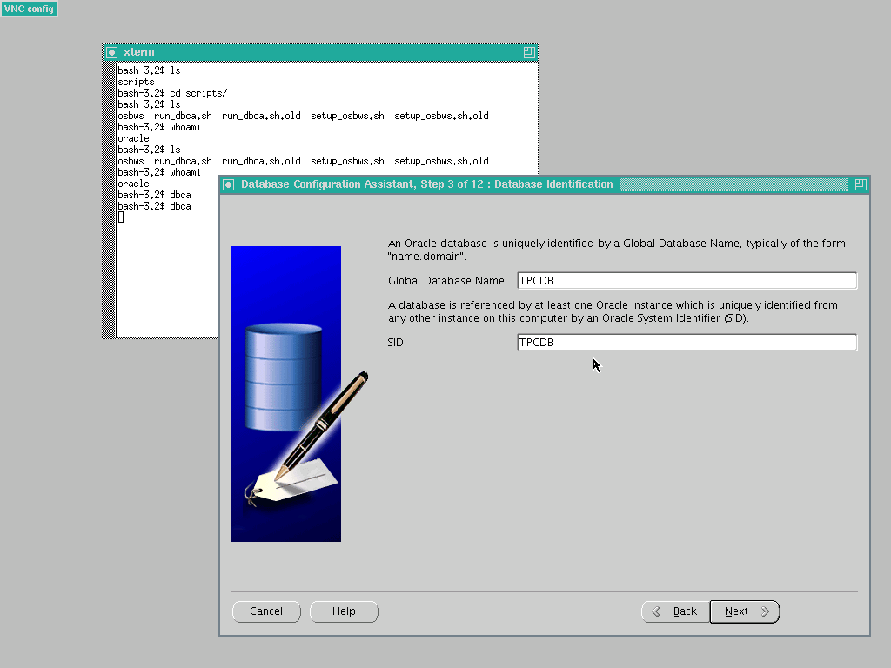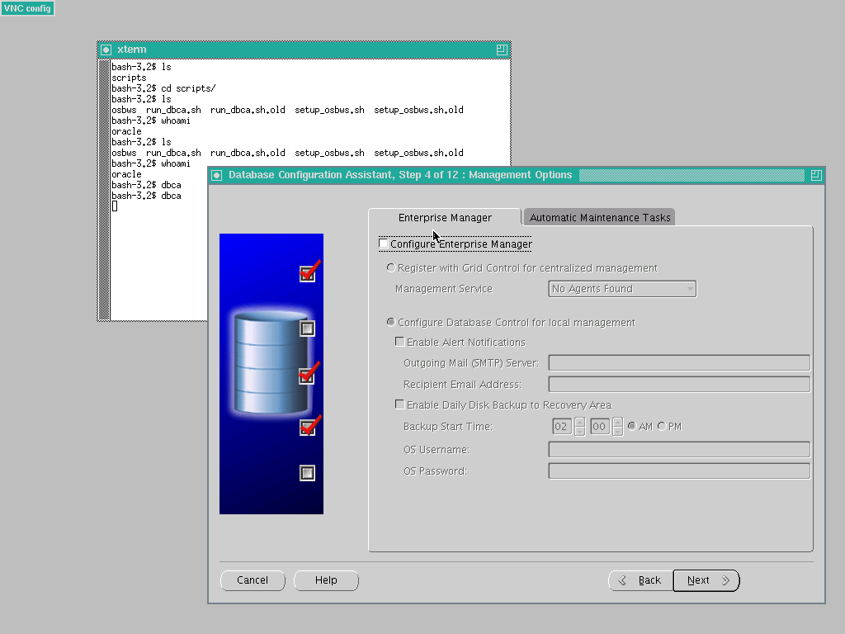 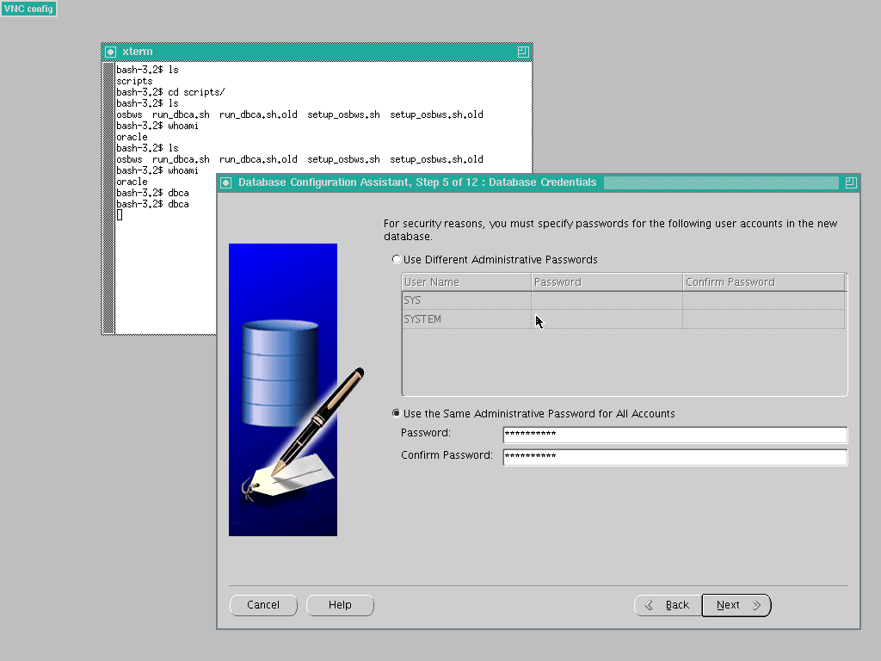
Pw= dbasupport
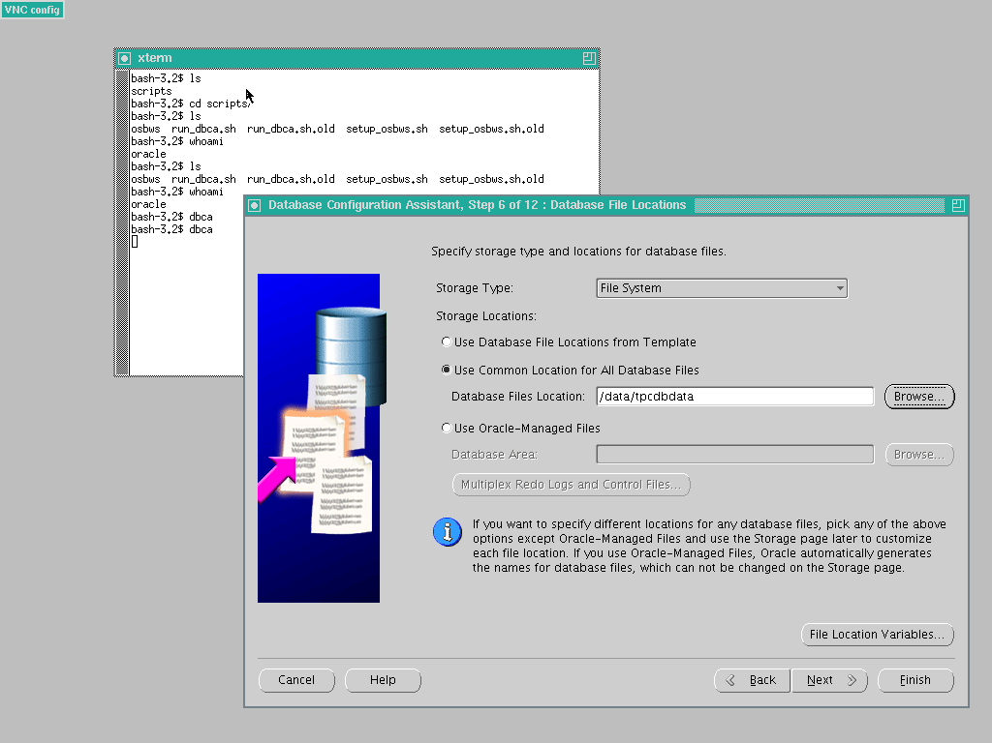
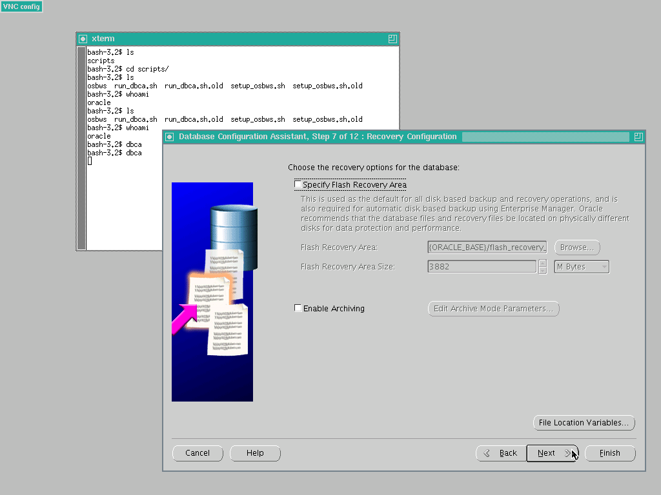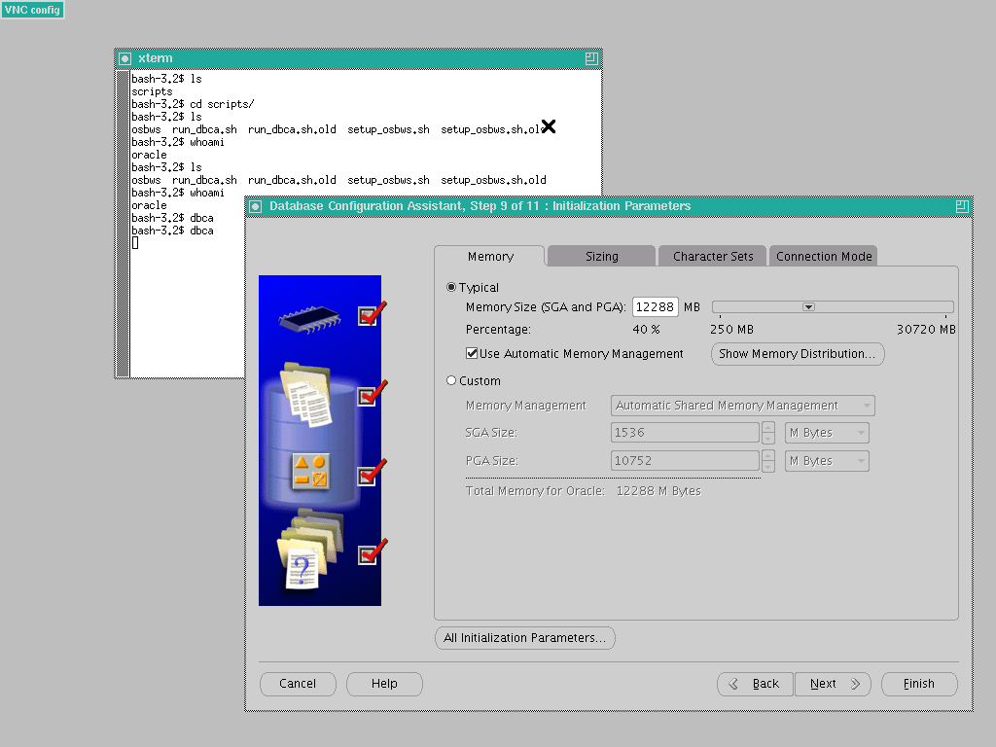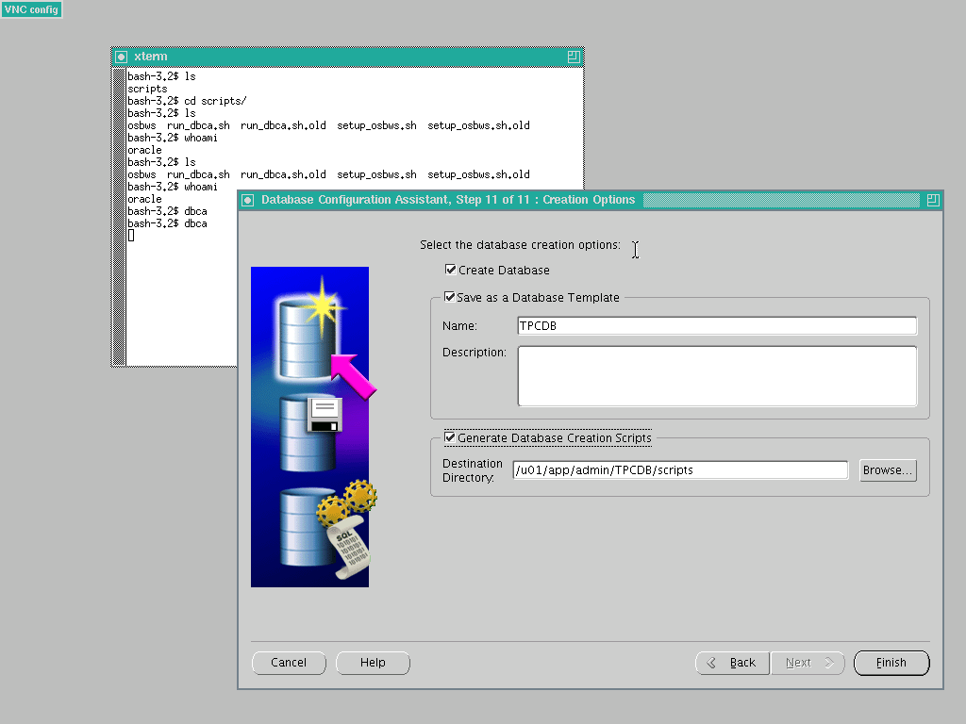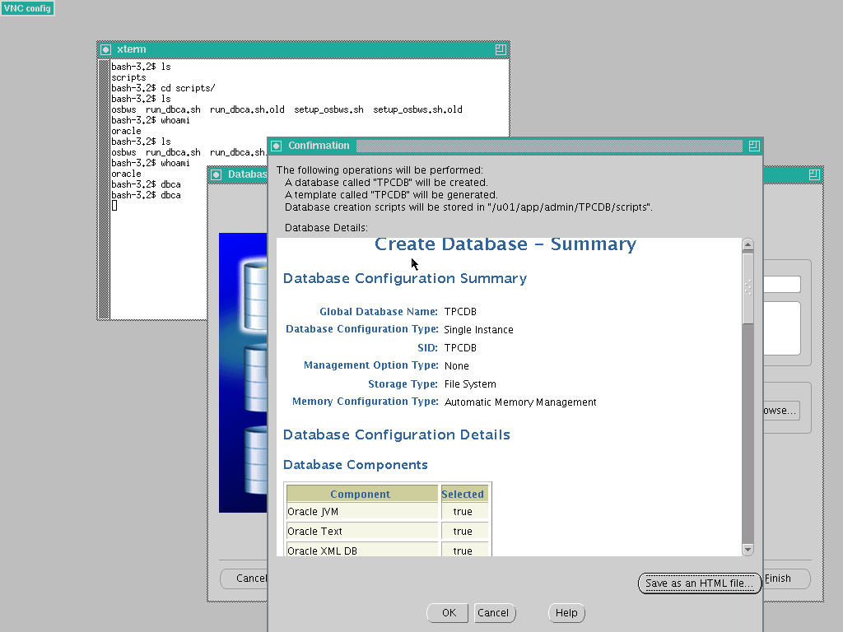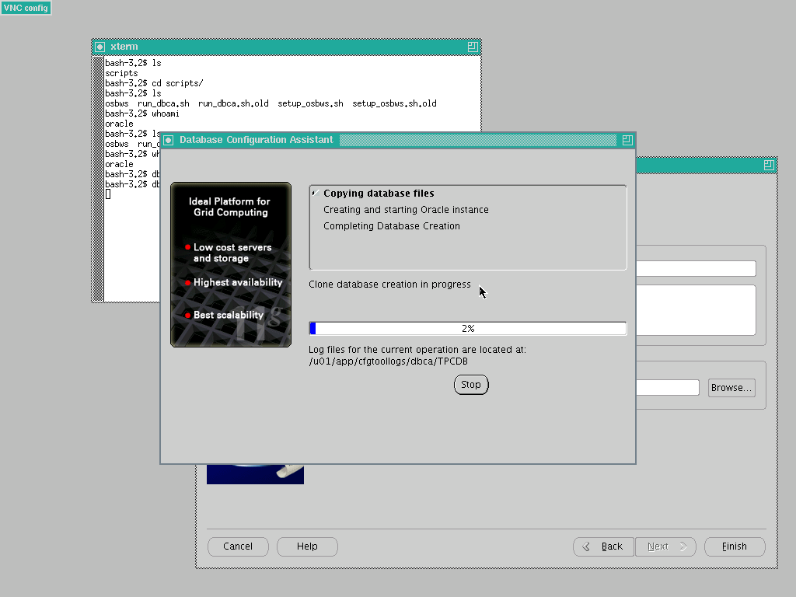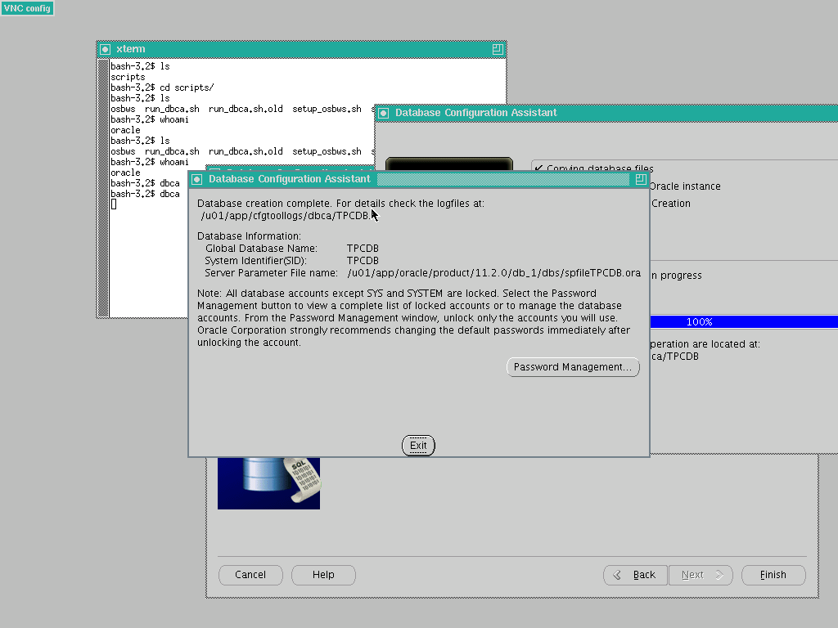
TNS:
TPCDB =
(DESCRIPTION =
(ADDRESS = (PROTOCOL = TCP)(HOST =10.0.10.14)(PORT = 1521))
(CONNECT_DATA =
(SERVER = DEDICATED)
(SERVICE_NAME = TPCDB)
)
)

